Nuclear Magnetic Resonance (ECX 300, JEOL)

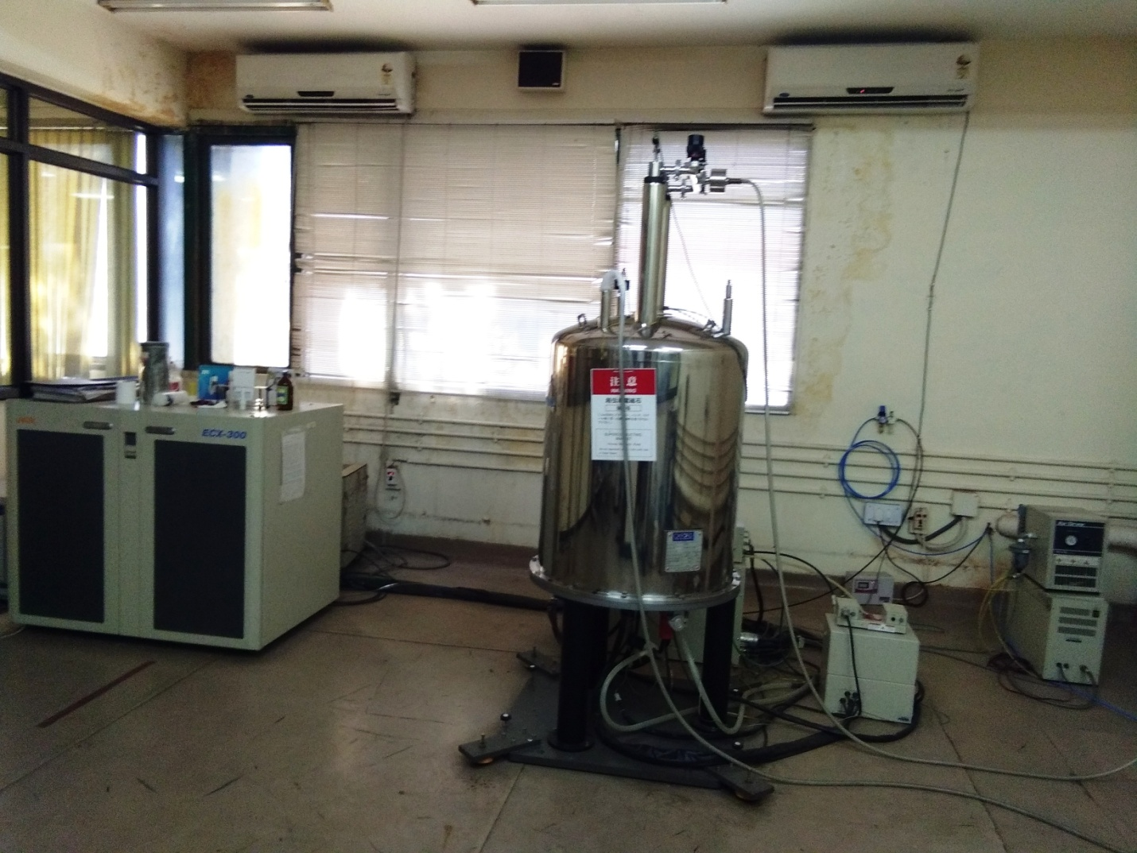

Sophisticated multinuclear FT NMR Spectrometer model ECX-300 (JEOL) is the latest acquisition in the Centre. The instrument is equipped with a cryomagnet of field strength 7.0 T. Its ¹H frequency is 300Mhz, while for ¹³C the frequency is 100 MHz.
The instrument is accompanied by Delta NMR data processing software and features complete spectrometer control for sophisticated multipurpose applications. Other highlights being,gradient shimming, auto shimming auto tuning and homo-hetronuclear de-coupling with 0.005Hz offset result.
A sensitive 5 mm multinuclear BBO probe allow to study a large number of NMR sensitive nuclei such as ¹⁹F, ³¹P. Instrument has facility to conduct experiments in the range of : -50ºC to+150ºC.

Analysis Features:
- 1D ¹H and ¹³C NMR Spectrum.
- Solvent suppression experiment.
- 2D COSY and HETCOR Experiments
DEPT-135, DEPT-90, DEPT-45 and QUAT experiments

Accessories Available: NMR tubes 5mm

Common solvent available:CDCl3, DMSO, D2O
Sample requirement: For 1H 10-20 mg;
For13C 50-60 mg;

Note: Samples should be sent in 2.0ml GLASS vials with sample properties like carcinogenic /Toxic for safe handling by NMR operator.

