DYNAMIC LIGHT SCATTERING ( Malvern Nano ZS)
Dynamic Light Scattering (also referred to as Photon Correlation Spectroscopy or Quasi-Elastic Light Scattering) is a technique used for the measurement of the size, electrophoretic mobility of proteins, zeta potential of colloids and nanoparticles, and optionally the measurement of protein mobility and micro rheology of protein and polymer solutions. The high performance of the Zeta sizer Nano ZS also enables the measurement of the molecular weight and second virial coefficient, A₂, of macromolecules and k_{D}, the DLS interaction parameter.

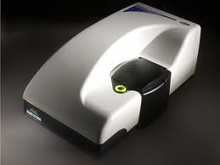
Specifications

Temperature control range: 0ºC - 90ºC +/-0.1
Light source: He-Ne laser 633nm, Max 5mW.
1. Measurement type: Size measurement
Measurement range: 0.3nm – 10.0 microns (diameter).
Minimum sample volume: 40µL
Accuracy: Better than +/-2% on NIST traceable latex standards
Precision/Repeatability: Better than +/-2%

2. Measurement type: Zeta potential
Measurement range: 3.8nm – 100 microns (diameter)
Measurement principle: Electrophoretic Light Scattering
Minimum sample volume: 150µL (20µL using diffusion barrier method)
Accuracy: 0.12µm.cm/V.s for aqueous systems using NIST SRM1980 standard reference material
Sensitivity: 10mg/mL (BSA).

3. Measurement type: Molecular weight determination
Measurement range: 980Da – 20M Da
Measurement principle: Static Light Scattering using Debye plot
Minimum sample volume: 40µL
Accuracy: +/- 10% typical

