ATOMIC FORCE MICROSCOPE (Veeco; Model: XE100 )

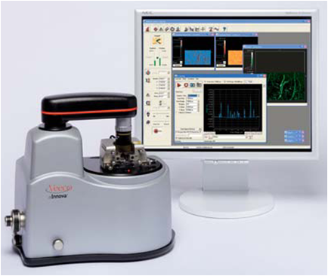
The Atomic Force Microscope (AFM) is a powerful instrument for nano-meter scale science and technology. Applications in the biosciences include: DNA and RNA analysis; Protein-nucleic acid complexes; Chromosomes; Cellular membranes; Proteins and peptides; Molecular crystals; Polymers and biomaterials; Ligand-receptor binding, Biomolecular force mapping. By using phase imaging technique one can distinguish the different components of the cell membranes.
Modes of operation

1. Contact Mode:

In this basic AFM mode of operation, the cantilever is in contact with the surface while imaging. The deflection of the cantilever is used for feedback and recorded as topographic data.
• Tip-sample distance control: Contact

2. Non-Contact Mode:

In True Non-Contact mode, a piezoelectric modulator vibrates a cantilever at a small amplitude and fixed frequency near the intrinsic resonance of the cantilever. As the tip is brought closer to the sample, the van der Waals attractive force between tip and sample influences the amplitude and phase of the cantilever’s vibration. These amplitude and phase changes are monitored by the patented Z-servo feedback system of the XE-series AFM, which maintains a tip-surface distance of just a few nanometers without damaging the sample surface. Precise control of the tip-sample distance, facilitated by the fast feedback performance of Park Systems’ high force Z-scanner, allows for imaging of the fine structure of a sample.
• Tip-sample distance : 3 nm (typical)
• Cantilever oscillation frequency: 1 - 600 kHz
• Cantilever oscillation amplitude: 1 - 2 nm (typical)

SPECIFICATIONS:
Close loop scanner: XY > 90 µm
Open loop scanner: XY > 50 µm,Z > 1.5 µm
Sample size: X-50mm x 50 Y-mm x Z – 18 mm
Motorized Z Axis Stage: Z Travel: 18mm
Optics:
Camera: on –axis color CCD with motorized zoom
Field of view: 1.24mm x 0.25mm
Resolution: <2µm with standard 10x objective [0.75µm with 50µm]
Sample Size: 15 mm diameter; 5 mm thick
Tip/ Cantilever Holders: Tapping mode/ contact mode in air.
Tapping mode/force modulation in fluid.
Force modulation in air; electrical field.
STM Converter
Low-current STM converter; contact mode fluid cell
Electrochemistry AFM or STM fluid cell
Electrochemistry tapping mode fluid cell
TR mode
Application Modules: SCM, TUNA, SSRM and CAFM

Microscope: Multimode V SPM head; choice of scanners

Accessories:
Completely Decoupled XY (50x50um) & Z scanner.
XY Scanner
Scane range: 50x50vµm
Resolution: <0.6vµm
Z scanner
Scane range: 12vµm

SLD Optical XE AFM head
Direct on-axis optical microscope
  - Magnification: 780x
  - Resolution: 1µm
  - Field of view: 480x360µm

High resolution digital camera with digital zoom
Effective picture elements: XGA 1032 x 778
Frame rate: Up to 20Hz
Digital zoom: Up to 100x

